

The San Mateo County Pride Center
Established in 2017 as a collaborative model organization and one-stop shop for the LGBTQ+ community. Operates as a program of StarVista and work in partnership with Peninsula Family Service and Outlet (a program of Adolescent Counseling Services) to offer robust programs and services to support LGBTQ+ community members of all ages.
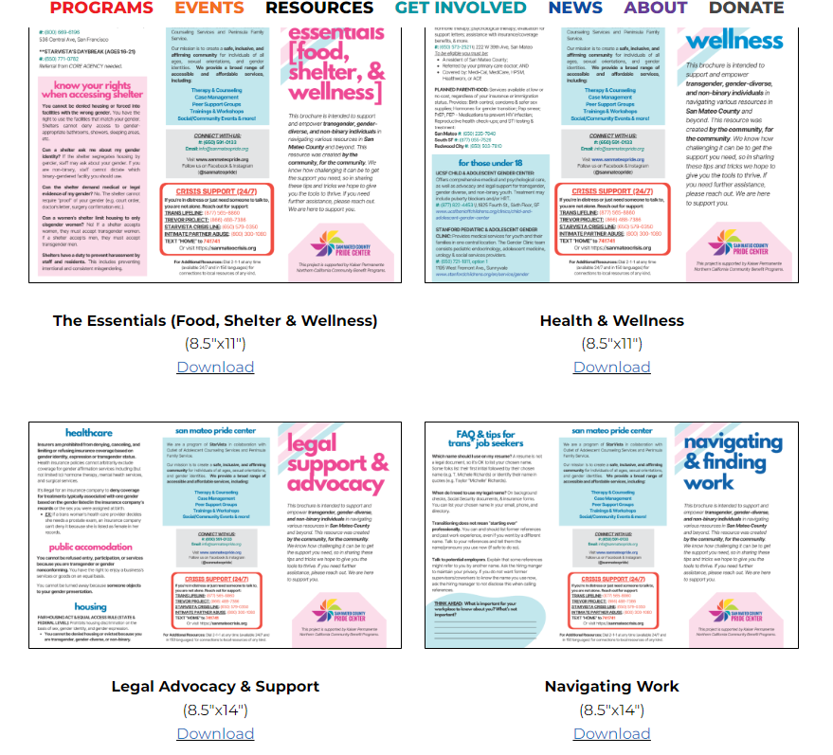
Resource Roadmaps: Intended to support and empower Transgender, Gender-Diverse, and Non-binary individuals in navigating various resources in San Mateo County and beyond. Brochures available for download with subjects: Housing, Physical/Mental Health, Employment, Legal Advocacy, and the Essentials (Food, Shelter & Wellness).

Programs:
- Case Management
- Crisis Intervention
- Mental Health Services
- Youth Services
- Peer Groups
- Resource Hub
- Upcoming Events
- Trainings & Consultations
- Community Space
  - Social, cultural and arts events
  - Educational workshops and trainings
  - Virtual gathering space for LGBTQ+ groups for support

